Geospatial backcasting mobile infrastructure deployment: An application to Mexico

1. Introduction

Broadband infrastructure has gone from an important factor in economic development, to an essential one, with enhanced provision rising up the policy agenda. Many recent assessments have highlighted the range of benefits which broadband services can provide once consumers and business are better connected, for example, with regard to Gross Domestic Product (GPD) (Koutroumpis, 2019; Minges, 2015), employment growth (Hjort and Poulsen, 2019; Ndubuisi et al., 2021), job productivity (Gallardo et al., 2020), unemployment (Lobo et al., 2020; Zuo, 2021), firm creation (Chen et al., 2023) and entrepreneurship (Hasbi, 2020).

Therefore, there is growing interest, particularly in Low- and Middle-Income Countries (LMICs), with how government may effectively facilitate the deployment of universal broadband, especially to rural and remote areas which may be poorly served. The hope is that enhanced investment in this broadband infrastructure will deliver new jobs, as well as having employment spillover effects into other new economic opportunities. Such policies require evidence on the impact of broadband deployment, motivating the focus of this paper. Unfortunately, we still lack high-quality spatial time-series data on the deployment of past infrastructure, motivating this analysis. This investigation will focus on evaluating mobile infrastructure deployment in Mexico, with recent coverage levels illustrated within Figure 1 by cellular generation.

Figure 1 Existing network coverage in Mexico (Collins Bartholomew, 2020)

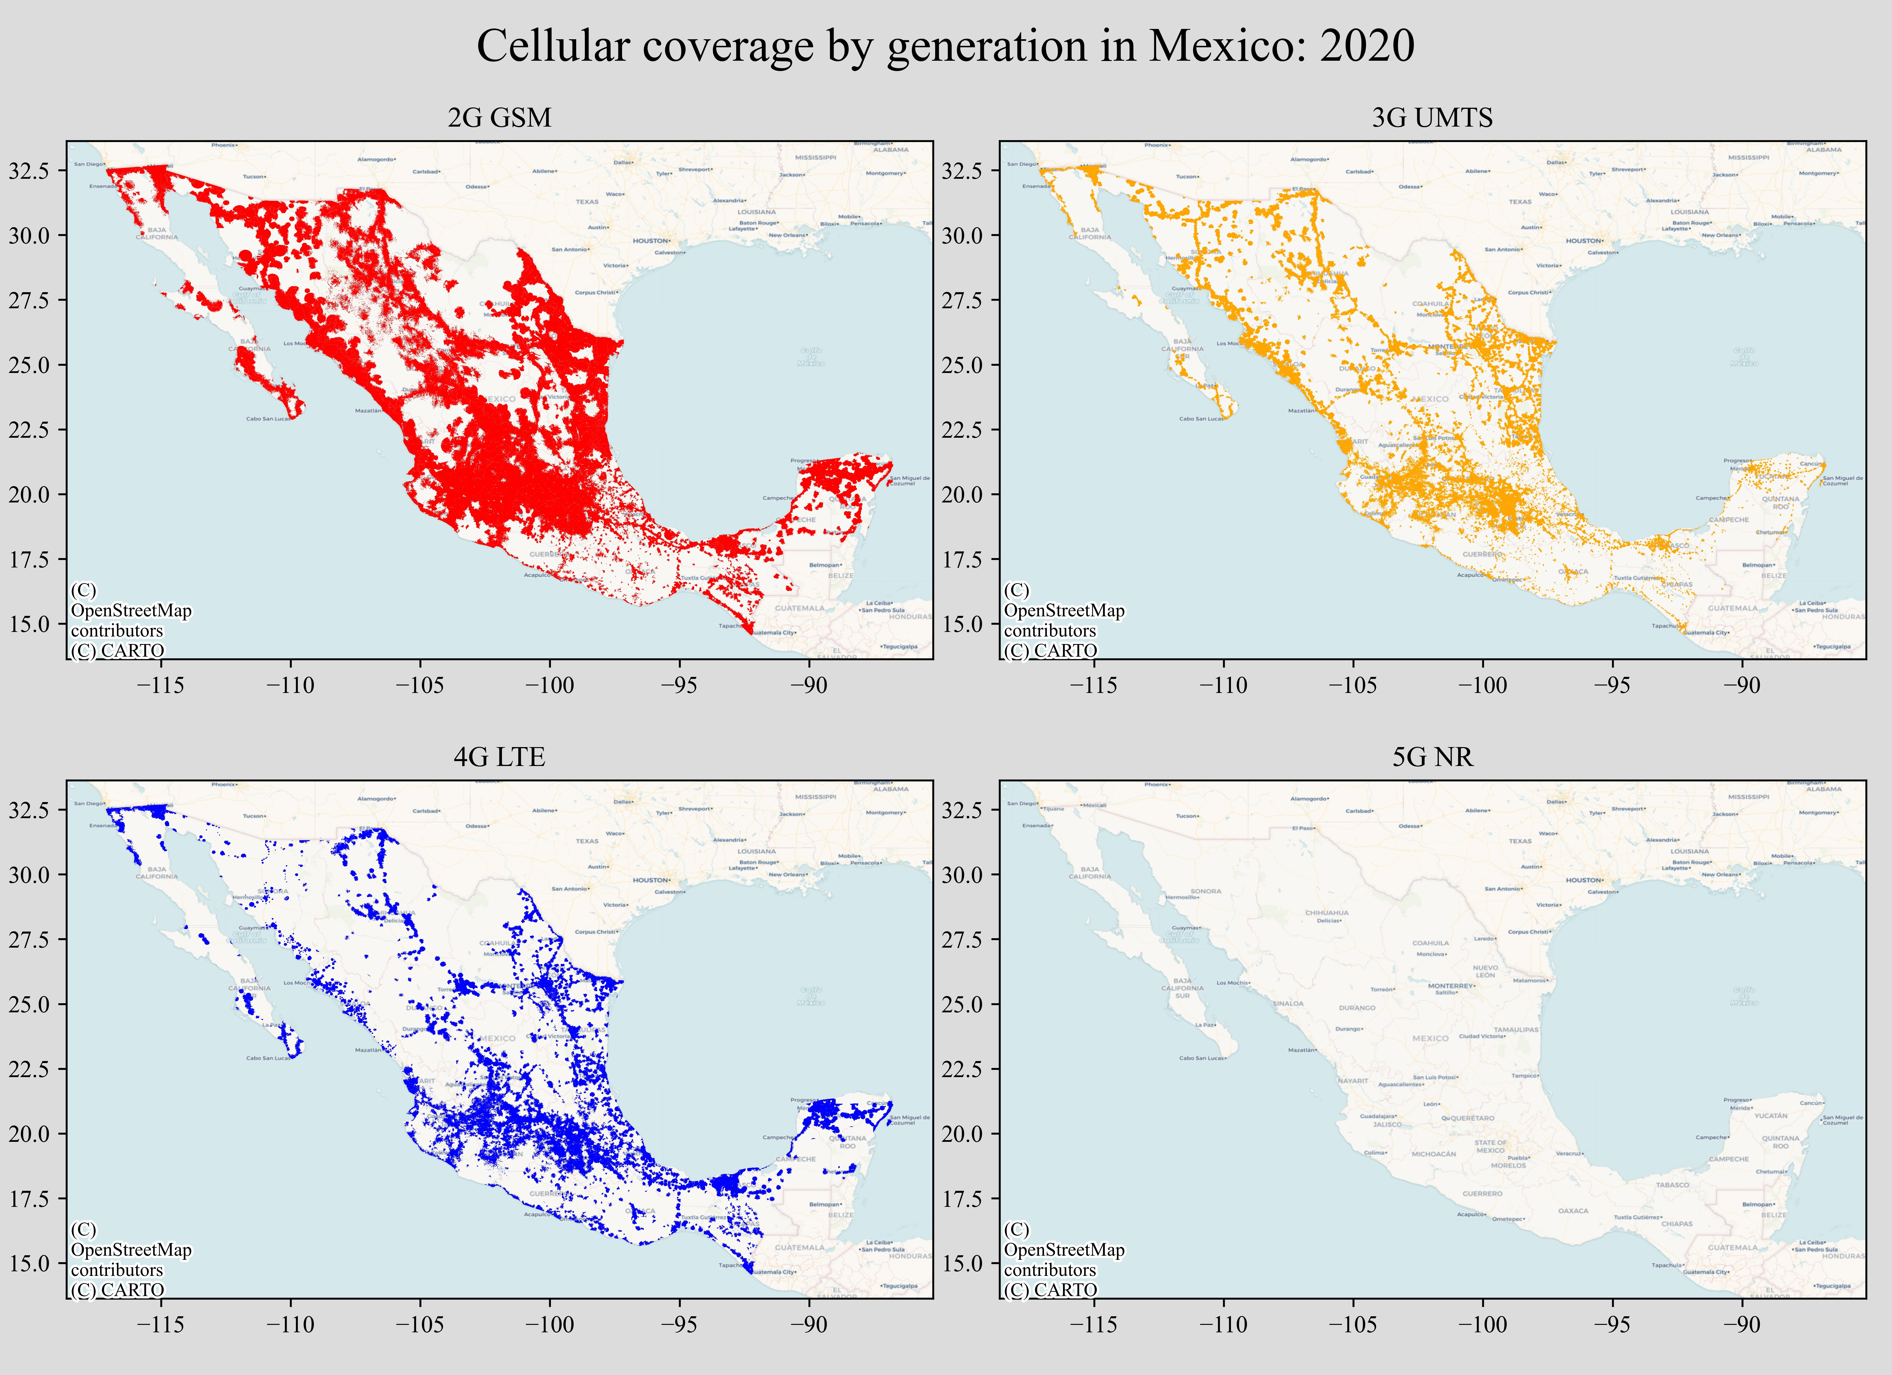

Whereas High-Income Countries have many decades of investment in fixed (‘wireline’) telecommunication infrastructure, which has been progressively upgraded over time (fixed telephony and then fixed broadband), in LMICs mobile broadband is often the most common way to access the Internet. Making the availability of 2G, 3G, 4G and 5G cellular communications highly important for carrying out a range of basic Internet-enabled tasks, from seeking economic opportunities, through to engaging with government. Each decade from the 1990s has seen a major generation of cellular technology deployed, beginning with the 2G Global System for Mobile (GSM) communications in the 1990s, to the Universal Mobile Telecommunications System (UMTS) in 3G in the 2000s, and then the Long Term Evolution (LTE) 4G from the 2010s onwards (Oughton and Lehr, 2022). This evolution has led to changing economic routines and practices, which over time induces structural economic change in local economies (with employment shifting towards newer economic activities).

1. Method

Here, a method is developed based on a synthetic investment attractiveness index, which is then used to develop a spatio-temporal “backcast” of mobile infrastructure deployment in Mexico. The spatio-temporal analysis of broadband infrastructure deployment has been explored in the literature. Although the standard approach is to explore this from an *ex ante* perspective (Oughton and Frias, 2018; Oughton and Russell, 2020), there are assessments also considering an *ex post* approach (Benseny et al., 2019; Chen et al., 2023).

The method here is predicated on the idea that Mobile Network Operators (MNOs) are rational economic actors that generally seek to profit maximize, and therefore deploy capital to infrastructure investments in locations which provide (i) the greatest utility to subscribers, and therefore (ii) provide the best overall opportunity for generating profit. The role of population density is consequently pivotal in supporting viable mobile infrastructure deployment, especially as high densities enable economics of scale (Benseny et al., 2019). The widespread use of flat-rate pricing in mobile services also reinforces this dynamic, as users in harder-to-reach areas cannot easily be charged more. Figure 2 visualizes population density for Mexico.

Figure 2 Spatial distribution of population density in Mexico

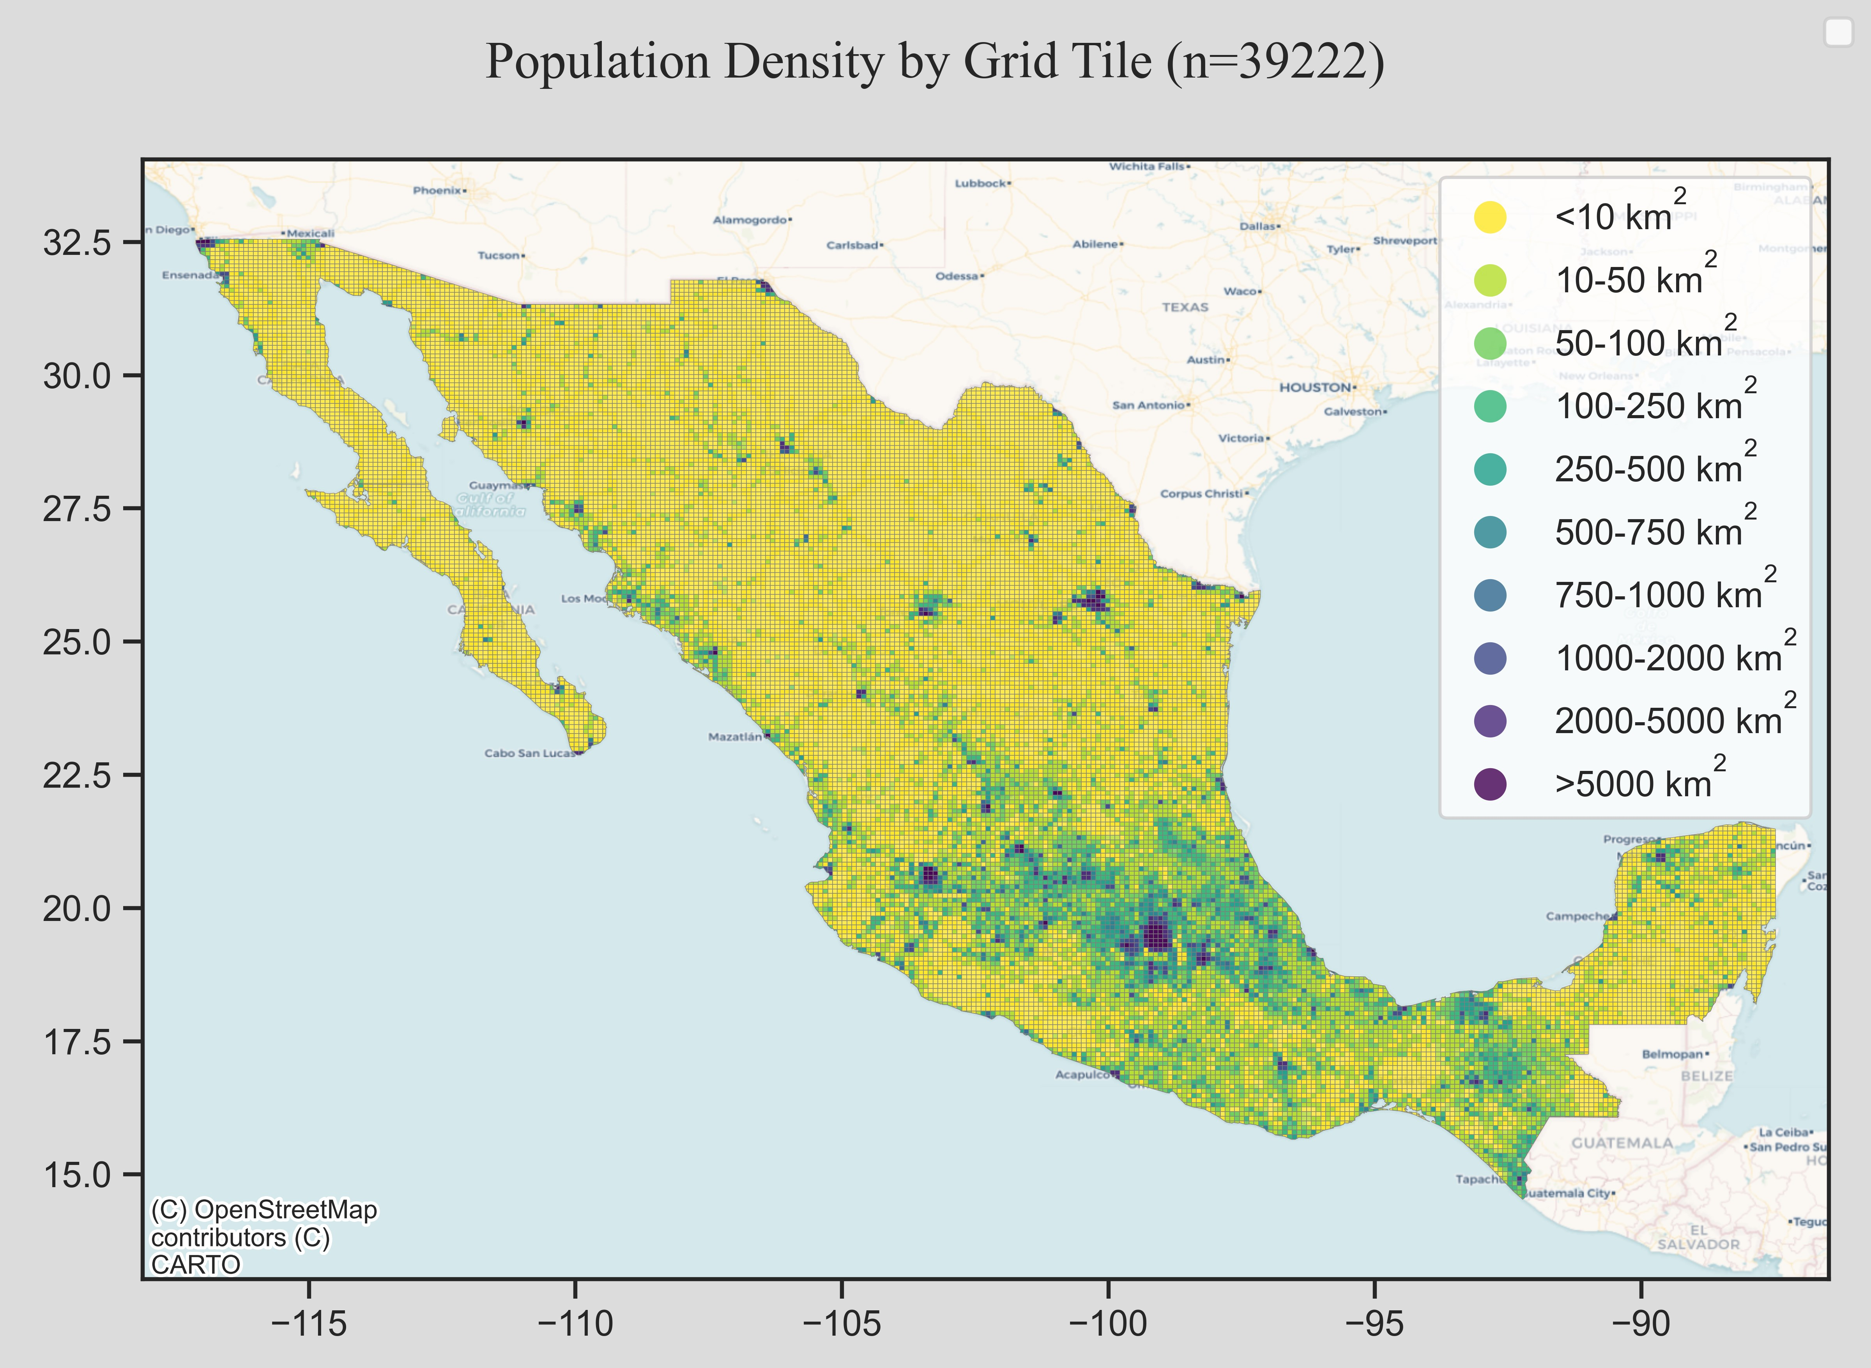

However, there are multiple dynamics at play, as subscribers are not static in their usage and mobile networks are named in essence of their key enabling property, to provide *mobility*. For example, while many assessments focus on building out infrastructure to where the population density is highest, MNOs also aim to cover other locations, including transportation networks (as subscribers gain utility from being connected across space). Figure 3 illustrates the key types of road infrastructure which require services from mobile infrastructure.

Given this context, Equation (1) details the approach of estimating investment attractiveness (${Attractiveness}_{i}^{}$) in the $i$ th grid tile, after the target country is divided into a 10x10 km2 grid.

|  |  |
| --- | --- |
|  | (1) |

Figure 3 Visualization of motorway, primary, secondary and tertiary road segments

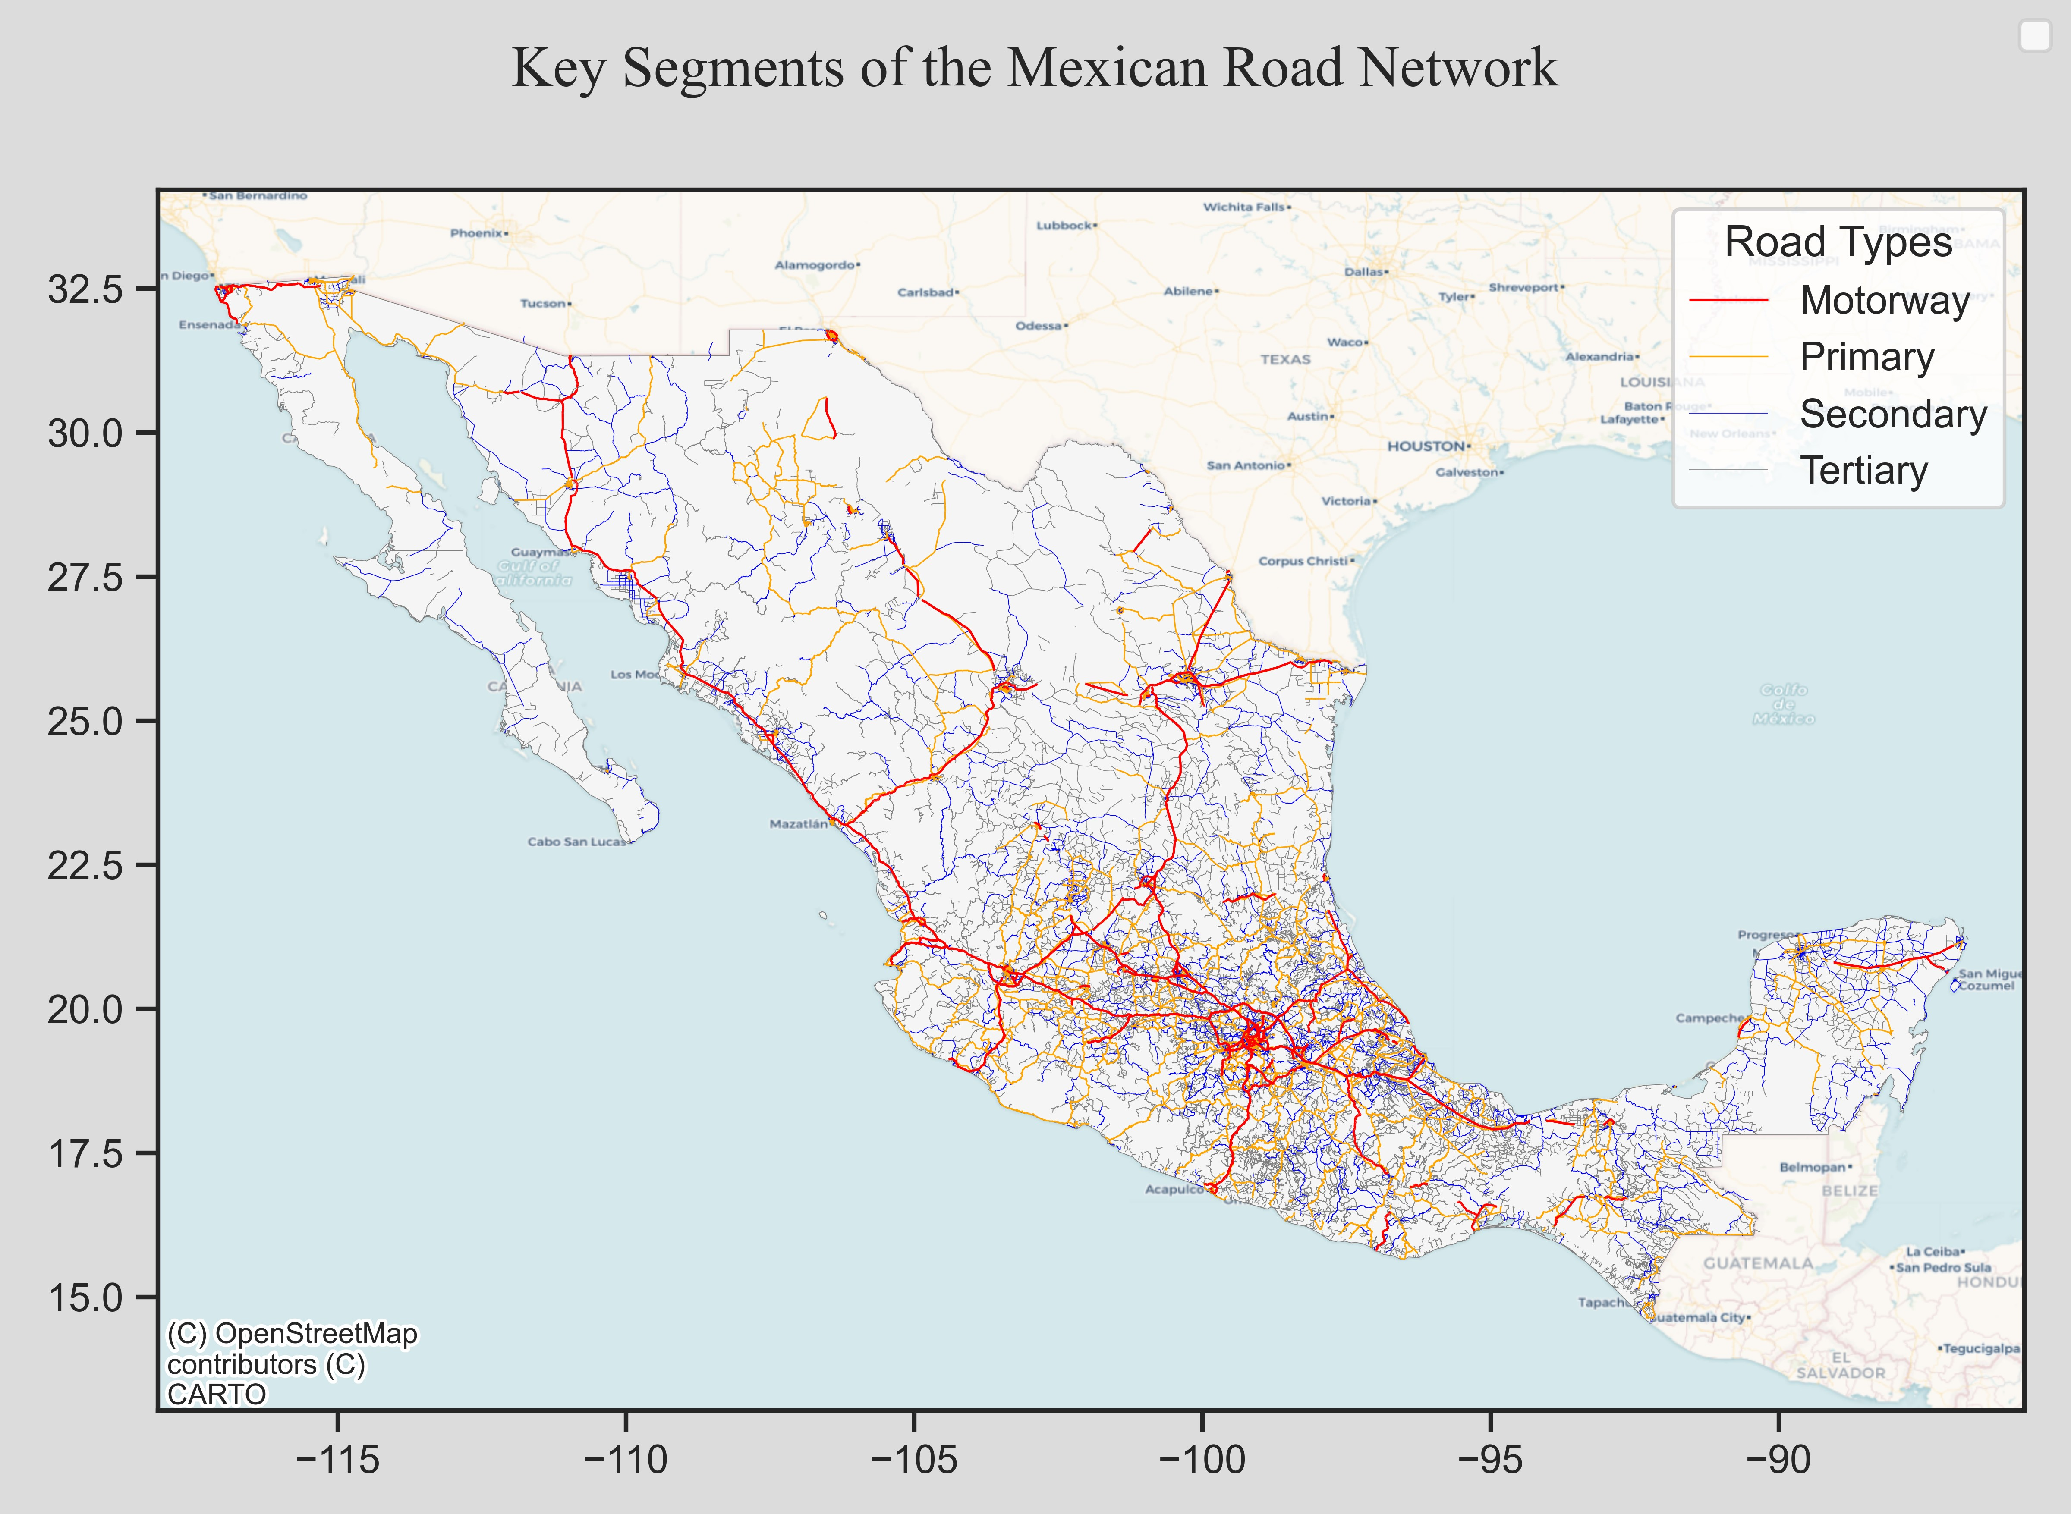

For each $i$ th grid tile, the population density (${PopDen}_{i}$) is estimated based on the WorldPop global 1 km2 mosaic. Followed by the segmentation of the OpenStreetMap road network, enabling estimation of the length of motorway (${Motorway}_{i}$), primary (${Primary}_{i}$), secondary (${Secondary}_{i}$) road infrastructure, based on the OSM principal tags which represent the importance of each stretch of road. The sources of data and their relevant descriptions are listed in Table 1.

Table 1 Sources of data

|  |  |  |
| --- | --- | --- |
| **Source** | **Description** | **Reference** |
| OpenStreetMap | A geospatial open-source database of the built environment, including transportation infrastructure assets. | (OpenStreetMap, 2023) |
| WorldPop | Mosaiced 1 km2 resolution global population dataset. | (Tatem, 2017; WorldPop, 2019) |
| Mobile Coverage Explorer | A geospatial representation of the area covered by mobile networks. | (Collins Bartholomew, 2020) |
| Database of Global Administrative Areas | A high-resolution database of country administrative areas. | (GADM, 2019) |

Each site is initially built using an estimated generalized capital expenditure cost of $150k, covering the active electronic radio equipment, tower construction, backhaul provision and power. Moreover, the backcast process is constrained using an annual estimated capital expenditure based on 20% of the modeled hypothetical MNO revenue. Thus, the revenue is estimated by multiplying the annual (i) mobile adoption, and (ii) the Average Revenue Per User (ARPU). The MNO is subsequently unable to spend more than this annual quantity building new sites and enhancing coverage.

Using data on unique subscribers, a time series on adoption is illustrated in Figure 4. For the 2010-2020 period, data are taken from the GSM Association (GSMA Intelligence, 2023). Prior to this, a logistic curve is fitted ($f\left(x\right)= \frac{L}{{1+e}^{-k(x-x_{0)}}}$) which ensures 10 million customer connections exceeded by the year 2000 (GSMA, 2016), and reaches beyond 49% by the year 2010, to become commensurate with the true GSMA data ($L$ =70, $k$ =0.09, $x_{0}$ =26).

Figure 4 Adoption of mobile services in Mexico

Next, the ARPU is estimated using a similar approach ($f\left(x\right)= \frac{L}{{1+e}^{k(x-x_{0)}}}$) ($L$ =40, $k$ =0.01, $x_{0}$ =0), with real data utilized for the 2010-2020 period, as visualized in Figure 5.

Figure 5 Estimated Average Revenue Per User (ARPU) in Mexico

This yields the estimated annual revenue, as reported below in Figure 6, for use in constraining the mobile network deployment backcast exercise.

Figure 6 Estimated annual capital expenditure

1. Results

In Figure 7 the outcome of the synthetic investment attractiveness index is visualized, illustrating the areas most attractive for MNOs to cover when deploying mobile infrastructure.

Figure 7 Synthetic index representing investment attractiveness

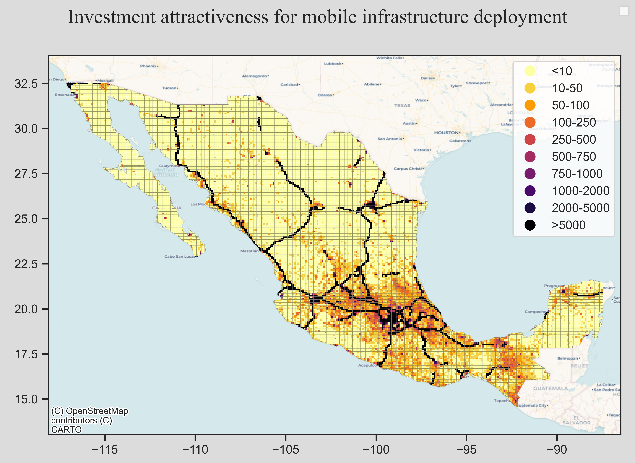

Using this index, and the constraints outlined in the method, Figure 8 reports the results of the backcast process for 2G GSM, followed by 3G UMTS in Figure 9 and 4G LTE in Figure 10.

Figure 8 Estimating of spatio-temporal deployment of 2G GSM

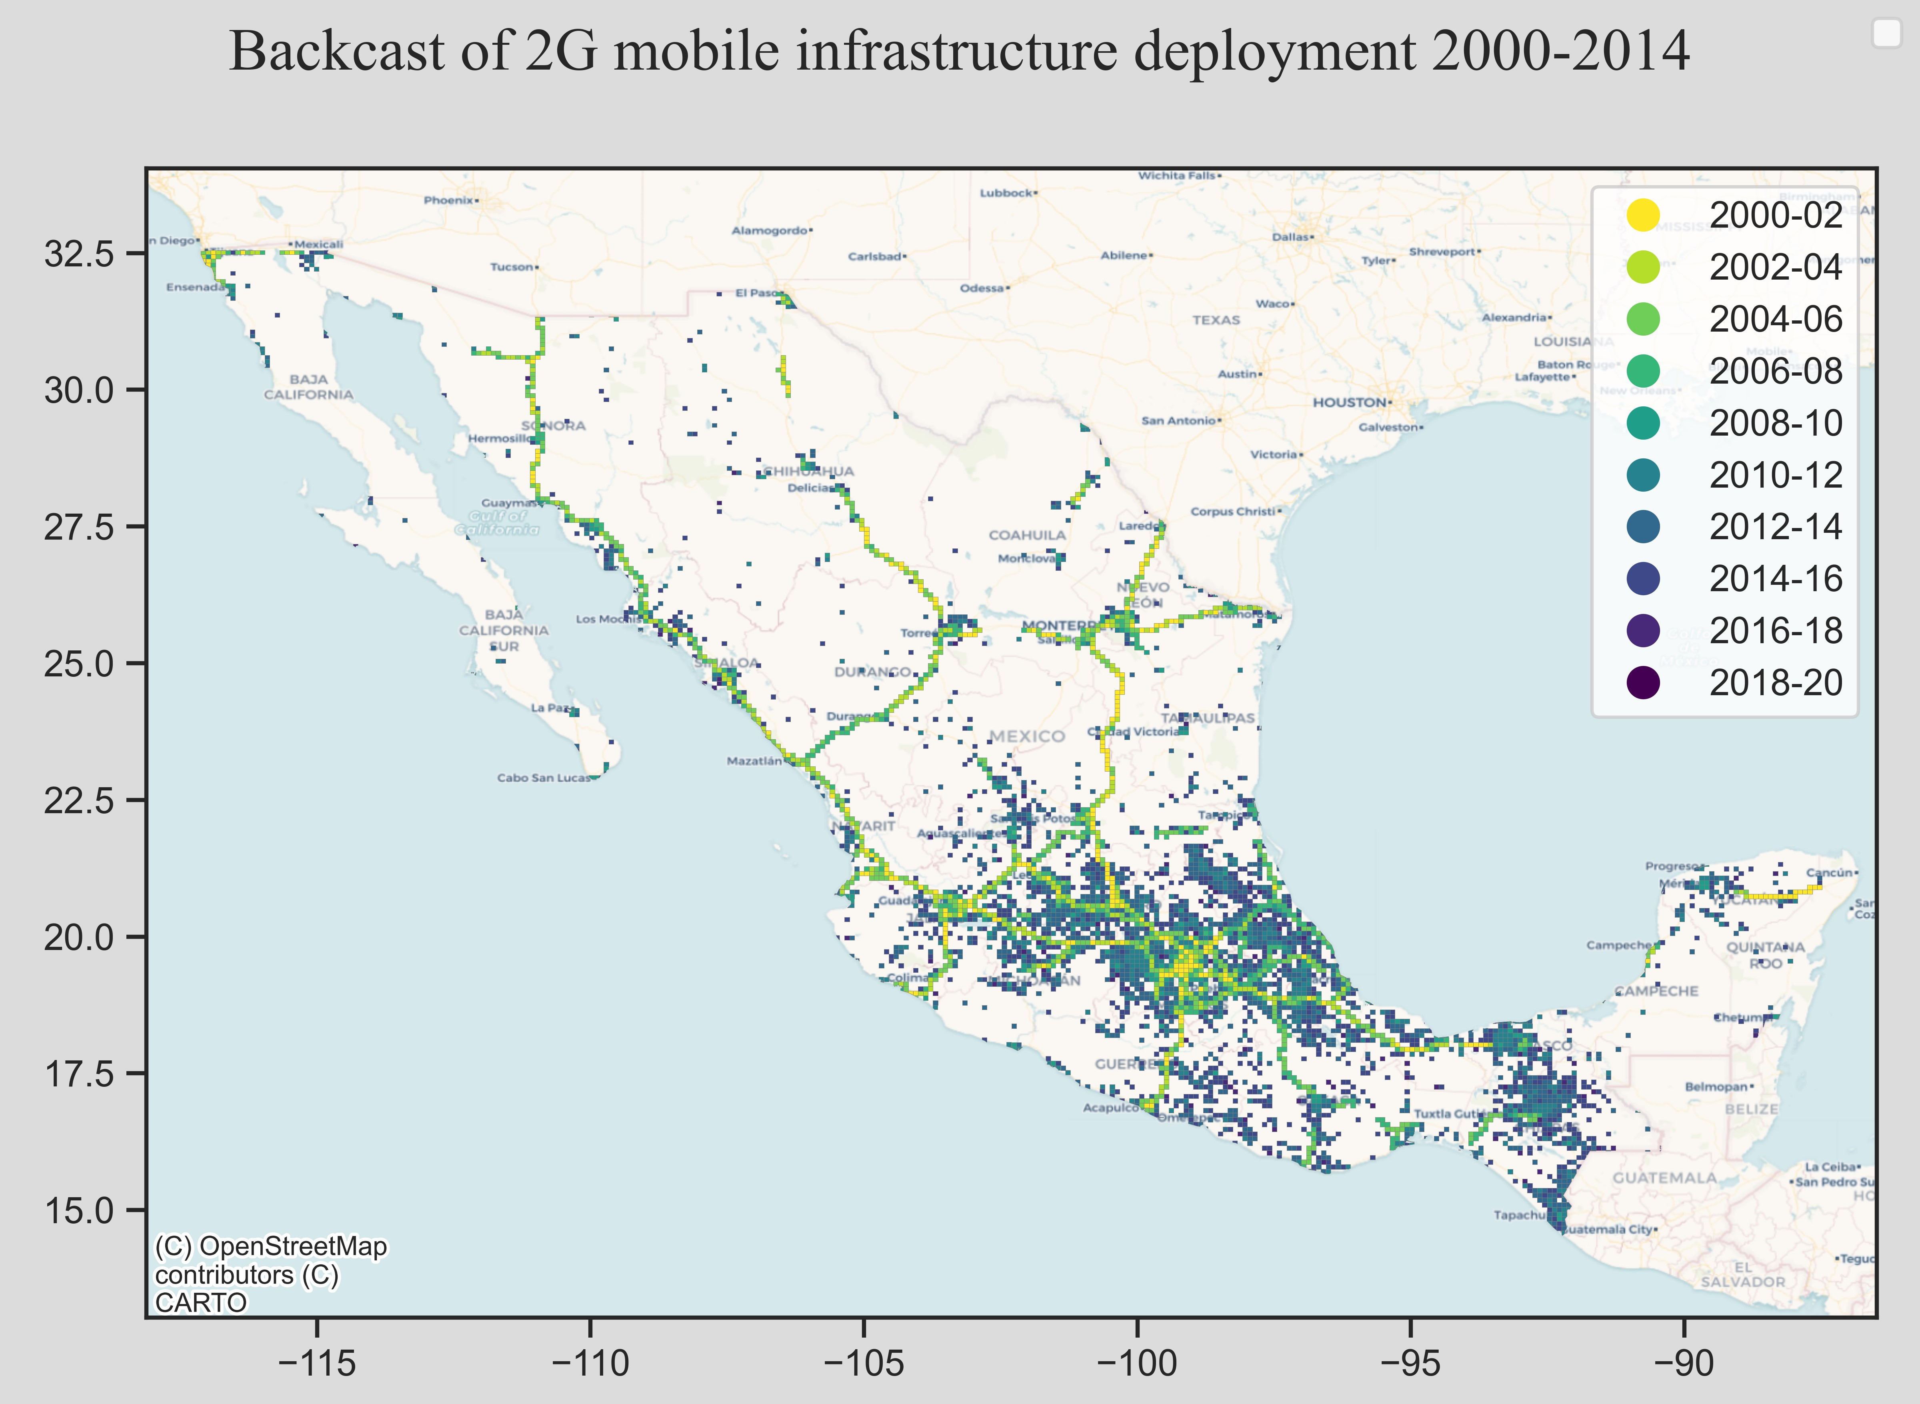

Figure 9 Estimating of spatio-temporal deployment of 3G UMTS

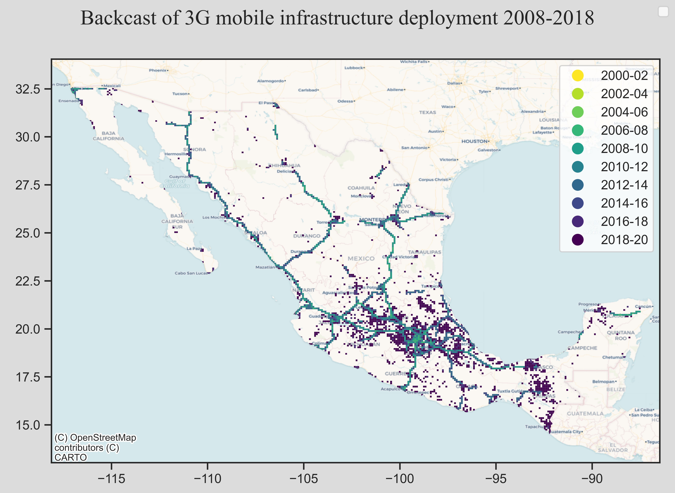

Figure 10 Estimating of spatio-temporal deployment of 4G LTE

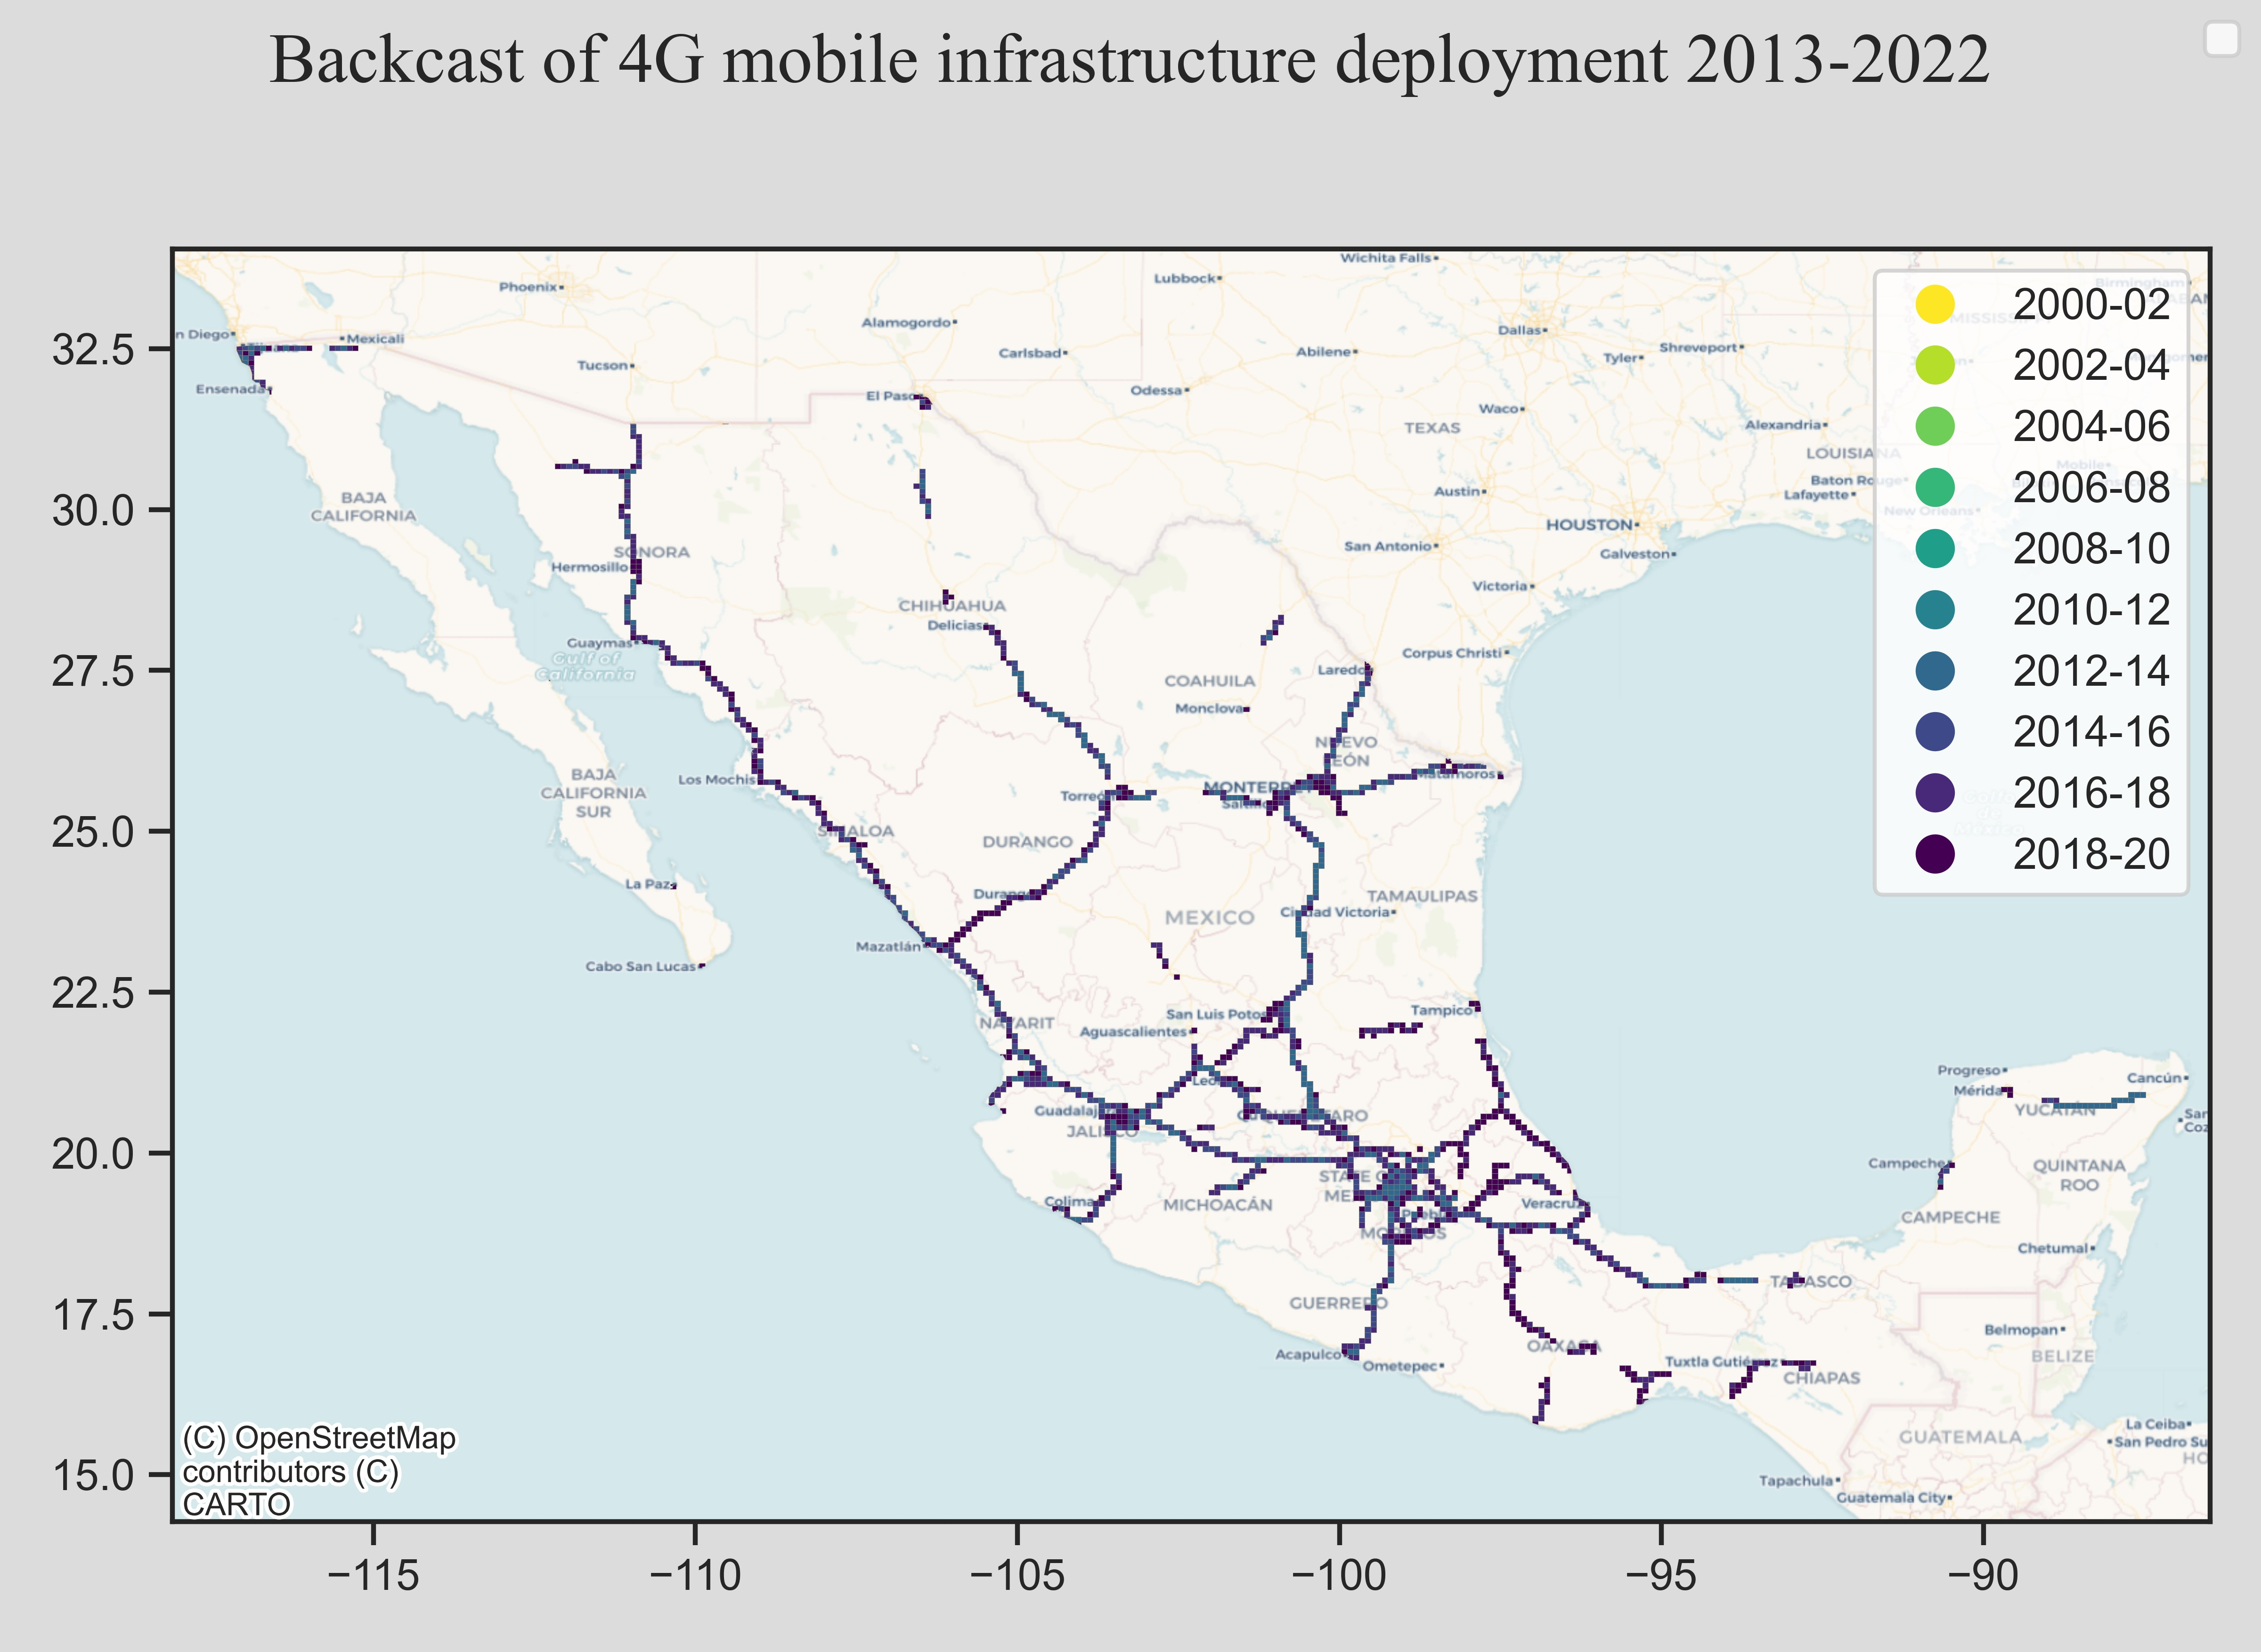

Finally, the population coverage of each generation from this geospatial backcast is presented in Figure 11 as a time series. The results illustrate that 2G GSM coverage reaches 98% population coverage by 2015, with 4G LTE on track to reach this level by 2022, commensurate with reported GSMA statistics (BNamericas, 2022).

Figure 11 Evaluating the effectiveness of the approach against existing data

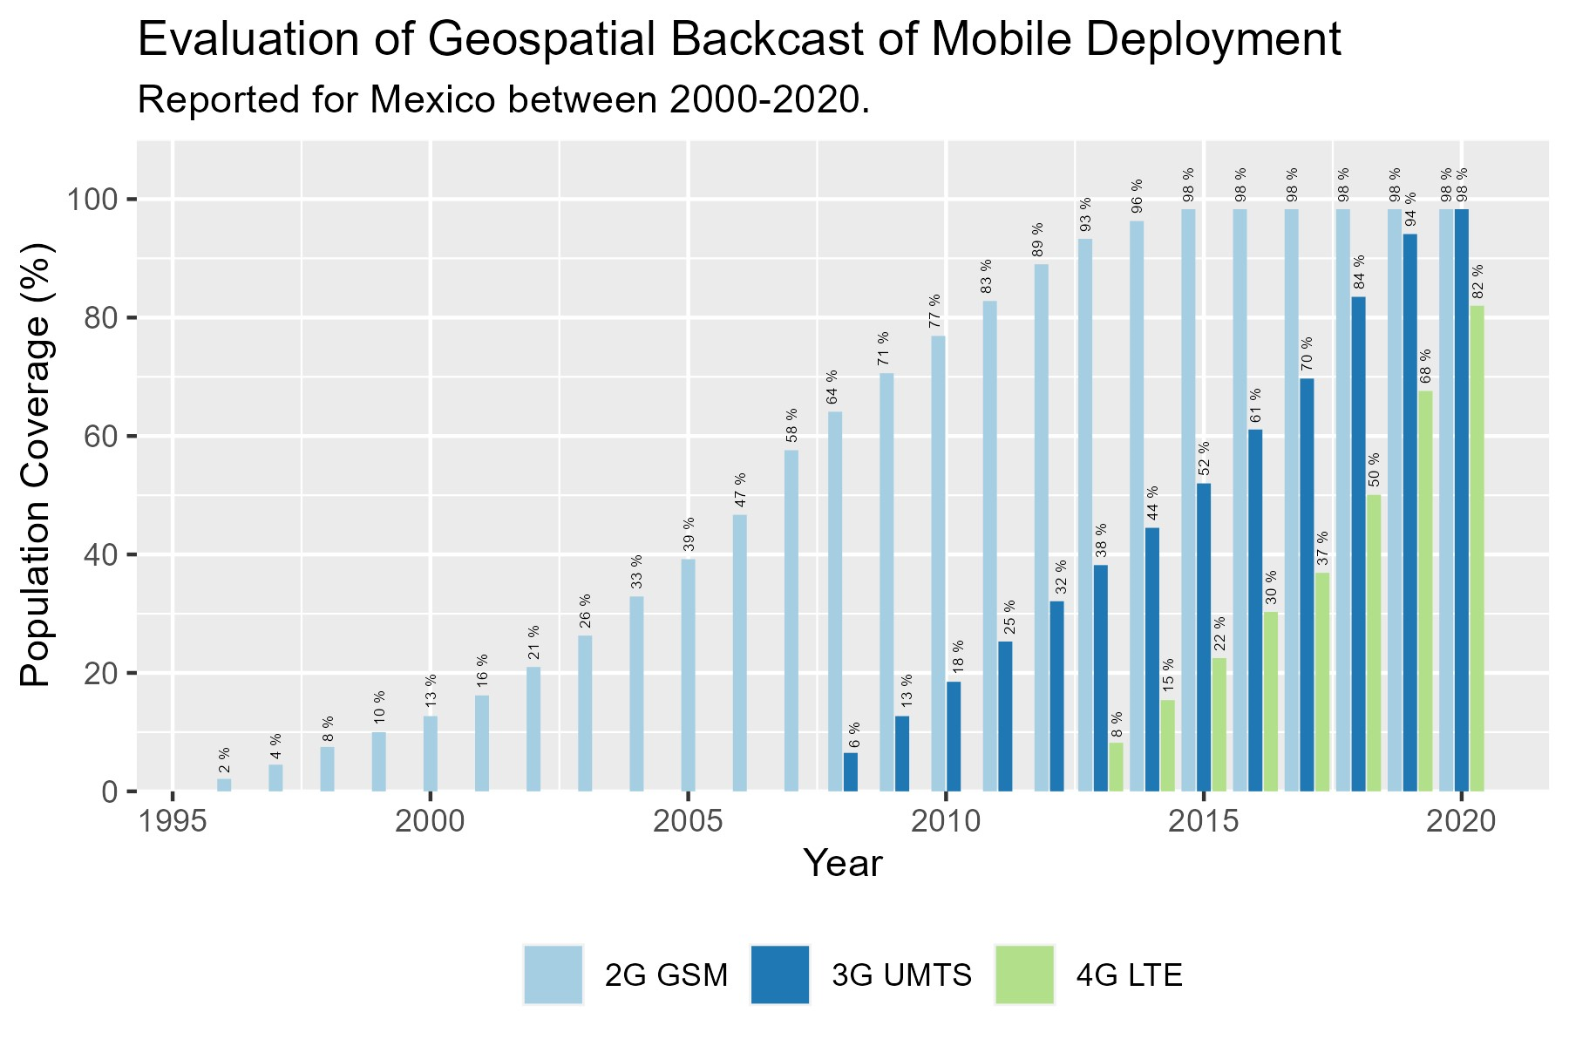

References

Benseny, J., Töyli, J., Hämmäinen, H., Arcia-Moret, A., 2019. The mitigating role of regulation on the concentric patterns of broadband diffusion. The case of Finland. Telemat. Inform. 41, 139–155. https://doi.org/10.1016/j.tele.2019.04.008

BNamericas, 2022. BNamericas - Mobile broadband network coverage reaches 96... [WWW Document]. BNamericas.com. URL https://www.bnamericas.com/en/news/mobile-broadband-network-coverage-reaches-96-of-latin-americas-population (accessed 12.15.23).

Chen, Y.P., Oughton, E.J., Zagdanski, J., Jia, M.M., Tyler, P., 2023. Crowdsourced data indicates broadband has a positive impact on local business creation. Telemat. Inform. 84, 102035. https://doi.org/10.1016/j.tele.2023.102035

Collins Bartholomew, 2020. Mobile coverage explorer [WWW Document]. CollinsBartholomew. URL https://www.collinsbartholomew.com/mobile-coverage-maps/mobile-coverage-explorer/ (accessed 5.18.20).

GADM, 2019. Global Administrative Areas Database (Version 3.6) [WWW Document]. URL https://gadm.org/ (accessed 7.11.19).

Gallardo, R., Whitacre, B., Kumar, I., Upendram, S., 2020. Broadband metrics and job productivity: a look at county-level data. Ann. Reg. Sci. https://doi.org/10.1007/s00168-020-01015-0

GSMA, 2016. Country overview: Mexico. Mobile driving growth, innovation and opportunity. GSM Association, London.

GSMA Intelligence, 2023. GSMA Intelligence is the definitive source of data and analysis for the mobile industry and beyond, covering all operators across the globe. [WWW Document]. GSMA Intell. URL https://www.gsmaintelligence.com/ (accessed 5.30.23).

Hasbi, M., 2020. Impact of very high-speed broadband on company creation and entrepreneurship: Empirical Evidence. Telecommun. Policy 44, 101873. https://doi.org/10.1016/j.telpol.2019.101873

Hjort, J., Poulsen, J., 2019. The Arrival of Fast Internet and Employment in Africa. Am. Econ. Rev. 109, 1032–1079. https://doi.org/10.1257/aer.20161385

Koutroumpis, P., 2019. The economic impact of broadband: Evidence from OECD countries. Technol. Forecast. Soc. Change 148, 119719. https://doi.org/10.1016/j.techfore.2019.119719

Lobo, B.J., Alam, M.R., Whitacre, B., 2020. Broadband speed and unemployment rates: Data and measurement issues. Telecommun. Policy 44, 101829. https://doi.org/10.1016/j.telpol.2019.101829

Minges, M., 2015. Exploring the relationship between broadband and economic growth.

Ndubuisi, G., Otioma, C., Tetteh, G.K., 2021. Digital infrastructure and employment in services: Evidence from Sub-Saharan African countries. Telecommun. Policy 45, 102153. https://doi.org/10.1016/j.telpol.2021.102153

OpenStreetMap, 2023. OpenStreetMap [WWW Document]. OpenStreetMap. URL https://www.openstreetmap.org/ (accessed 11.13.23).

Oughton, E.J., Frias, Z., 2018. The cost, coverage and rollout implications of 5G infrastructure in Britain. Telecommun. Policy, The implications of 5G networks: Paving the way for mobile innovation? 42, 636–652. https://doi.org/10.1016/j.telpol.2017.07.009

Oughton, E.J., Lehr, W., 2022. Surveying 5G Techno-Economic Research to Inform the Evaluation of 6G Wireless Technologies. IEEE Access 10, 25237–25257. https://doi.org/10.1109/ACCESS.2022.3153046

Oughton, E.J., Russell, T., 2020. The importance of spatio-temporal infrastructure assessment: Evidence for 5G from the Oxford–Cambridge Arc. Comput. Environ. Urban Syst. 83, 101515. https://doi.org/10.1016/j.compenvurbsys.2020.101515

Tatem, A.J., 2017. WorldPop, open data for spatial demography. Sci. Data 4, 1–4. https://doi.org/10.1038/sdata.2017.4

WorldPop, 2019. WorldPop :: Population [WWW Document]. URL https://www.worldpop.org/project/categories?id=3 (accessed 1.2.20).

Zuo, G.W., 2021. Wired and Hired: Employment Effects of Subsidized Broadband Internet for Low-Income Americans. Am. Econ. J. Econ. Policy 13, 447–482. https://doi.org/10.1257/pol.20190648